Jamika Cook
Southern New Hampshire University
DAT-475: Applied Data Analysis
Professor Edwards
November 13, 2025

3-1 Project One Submission
- Develop a problem statement that accurately defines the organizational situation.
The company builds electronic boards through a process that begins with placing the Thru-Hole components onto the boards. From there, the assembly is welded using the wave soldering machine. Once welding is complete, the boards are sent to the quality inspection workstation, where a quality worker checks for welding defects. After approval, the boards move to another production line for additional assembly. Recently, the company has experienced an increase in demand for its electronic boards, and at the same time, there has been a spike in defects in both the welding process and the Thru-Hole components. Some of these defects include solder bridges, missing, damaged, or lifted components, and insufficient or excessive solder. This increase in defects has led to a noticeable rise in assembly and electronic testing problems during the final assembly process.
This issue is significant because the company must comply with the IPC-A-610E quality acceptability standards for electronic assemblies. Currently, the boards do not meet several of these welding criteria, including smooth solder filaments, good wetting conditions, and no surface imperfections. Based on recent findings, it was also determined that fixing defects after final assembly is cost-prohibitive, as it requires too many production hours and workers with highly specialized skill sets. For this reason, the company finds it necessary to correct these welding defects before the final assembly stage. This improvement project has two primary goals: (1) to reduce the defects generated during the welding process of the three double production lines in the Manual Finish area by 20%, and (2) to increase the capacity of these production lines by 20% without increasing the defect percentage.
- Identify the most significant cause(s) of the identified organizational problem
- Top models with defects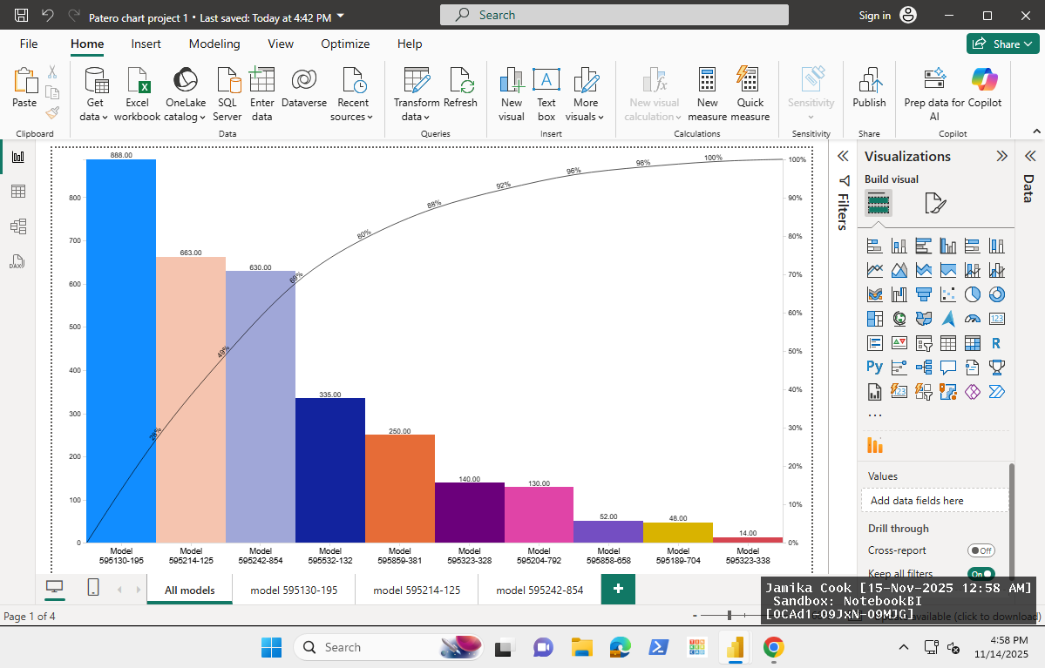
- Top defects within the top 3 models with defects
- Defects for the model 595130-195
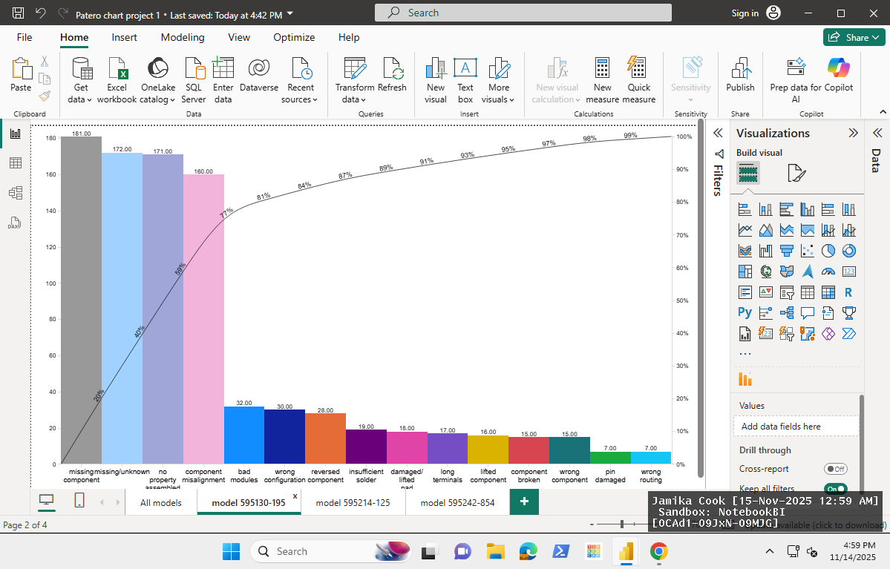
- Defects for the model 595214-125
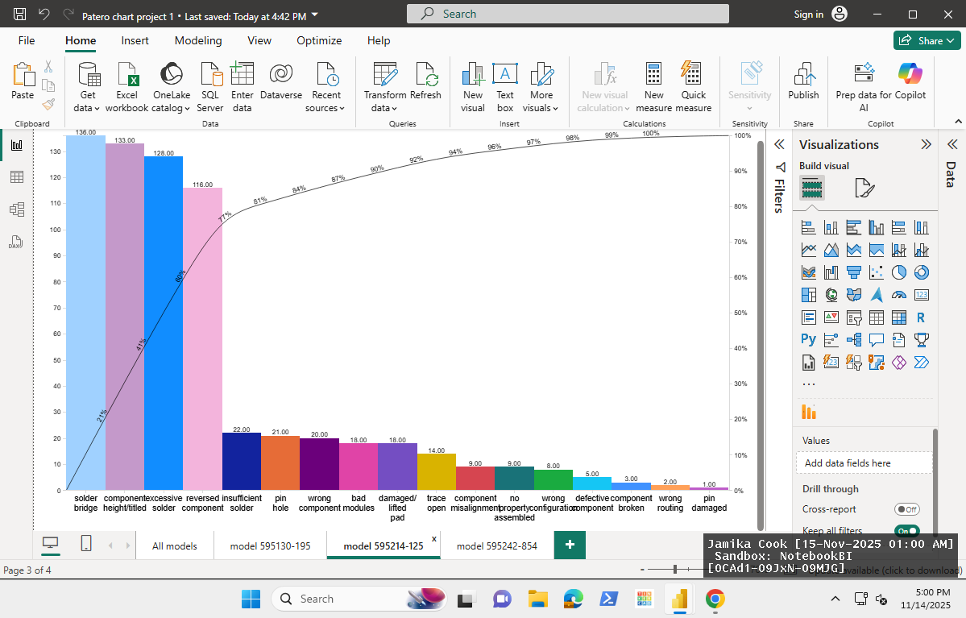
- Defects for the model 595242-854
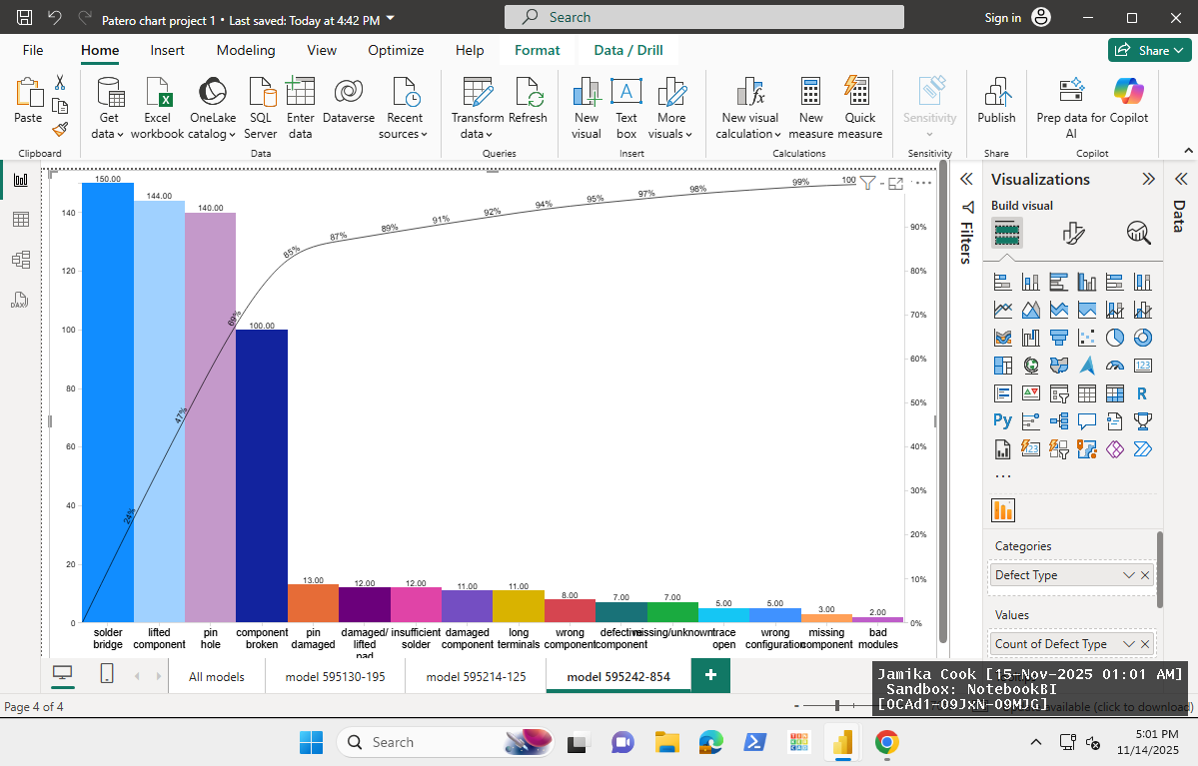
- Summarize the most significant causes of defects based on your analysis
The model that appears to have the most defects is the Model 595130-195 with 888 total defect counts. This accounts for roughly 28% of all defects. Next is the Model 595214-125 with 663 defect counts. This brings the cumulative total to around 51%. In third place is the Model 595242-854 with 630 total defects, raising the cumulative total to roughly 69%. Model 595532-132 has a total of 335 defects, bringing the cumulative total to 81%. According to the 80/20 rule, this means these 4 models should be prioritized for improvement.
By analyzing a little bit deeper, we are able to determine the top defects of these models. When it comes to the Model 595130-195, the top defect reported is missing components with 181 reports, followed by missing/unknown at 172, not properly assembled with 171, component misalignment at 160, and bad modules at 32. These 3 defects make up 81% of all defects for the model, indicating that a majority of the issues for this model revolve around an assembly issue.
For the Model 595242-854. Solder bridge has 136 reports, component height/tilted has 133, excessive solder has 128, reversed component has 116, and insufficient solder has 22, making up for 81% of all defects for the model. All of these defects appear solder-related, and by addressing the solder, we can alleviate 81% of the defects for this model. For Model 595242-854, the top four defects are solder bridge with 150 reports, lifted component (144), pin hole (140), and component broken (100). These make up approximately 85% of all defects for the model.

Missed visual cues
Measurements
Poor inspection prior to welding
Inadequate solder application checks
Thru-Hole components inconsistent in size
Poor solder adhesion quality
Worn/damaged tools
Fixture misalignment
Solder miscalibration
Machine
Inconsistent defect inspection criteria
Human error in visual inspection
Inconsistent training
Incorrect component placement
People
Method

No automated measurement tools for verifying alignment or solder quality

Increased defects in the welding process, Manual Finish, are leading to delays and failure to meet the IPC-A-610E standards.

Quality of components causing breaks
No standardized placement procedure for Thru-Holes

Material

The fishbone diagram shows several potential root causes that contribute to the defects in the Manual Finish welding process. Across categories such as People, Measurements, Machines, Method, and Materials, the most common themes include improper component placement, soldering machine miscalibration, and material quality issues. These factors directly contribute to the top defects revealed in the analysis. The Pareto charts support the root cause analysis by showing that only a handful of defects account for more than 80% of total defects for each model. For example, Model 59510-195 was dominated by assembly-related defects such as missing components and misalignment, which aligns with the “People” and “Method” categories in the fishbone. Models 595214-125 and 595242-854 had a huge number of defects in the solder bridge and pin hole, confirming issues related to “Machines’ and “Method”.
When comparing the individual model Pareto charts to the overall, I noticed clear patterns. While the full production Pareto chart shows a mix of both assembly and soldering issues, the model-specific chart reveals each line has its own prominent defects. Model 59510-195 shows primarily assembly errors, and models 595214-125 and 595242-854 show mostly solder-related defects. This indicates that improvement efforts must be tailored to each line rather than applied uniformly. For example, the most effective solutions will target training and component placement for Model 595130-195, while Models 595214-125 and 595242-854 will require improvements in soldering parameters, fixture alignment, and machine calibration. Addressing these root causes will support the company’s goal of reducing defects by 20% and increasing capacity without sacrificing quality.

Reference:
Southern New Hampshire University. (n.d.). DAT 475 Project Case Study: Welding process manual finish production floor[Case study]. https://learn.snhu.edu/content/enforced/2074670-DAT-475-13734.202586-1/course_documents/DAT%20475%20Project%20Case%20Study.pdf?isCourseFile=true&ou=2074670

